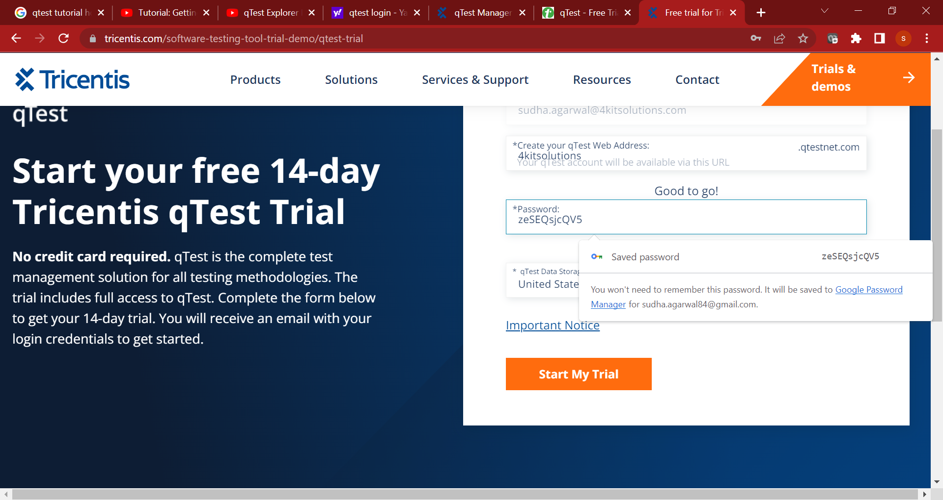

https://4kitsolutions.atlassian.net/browse/B4S-31